WTAA Merchandise
Shirts & Gym bag contact: wtaa@centennialsd.org
Glass tumblers contact: dichfr@centennialsd.org

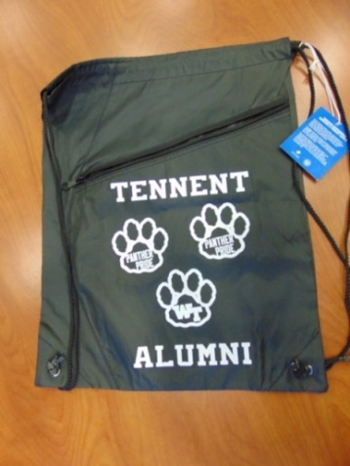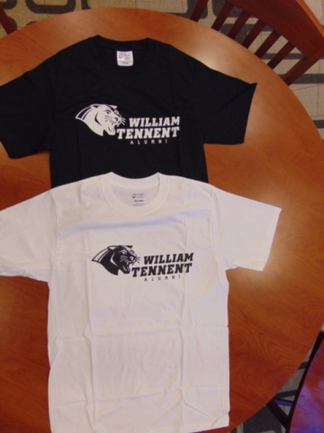
WTAA Bag Black $10.00 ea. Glass Tumbler $8.00 Ea. Short sleeved t-shirts
Or Two for $15.00 (Black or White) $10.00 ea.
Add $2.00 for size 2xl

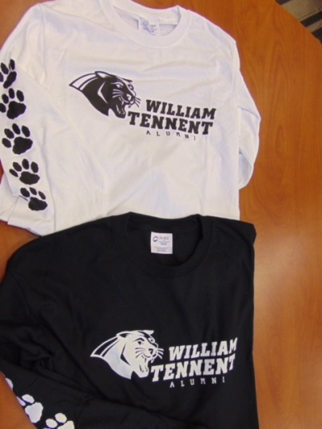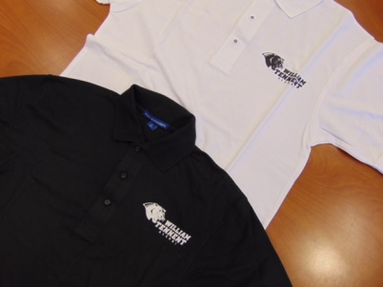
Long sleeved T-Shirts Golf Shirts
(Black or White) $15.00 ea. (Black or White) $25.00 Ea.
Add $2.00 for size 2xl add $2.00 for size 2xl

